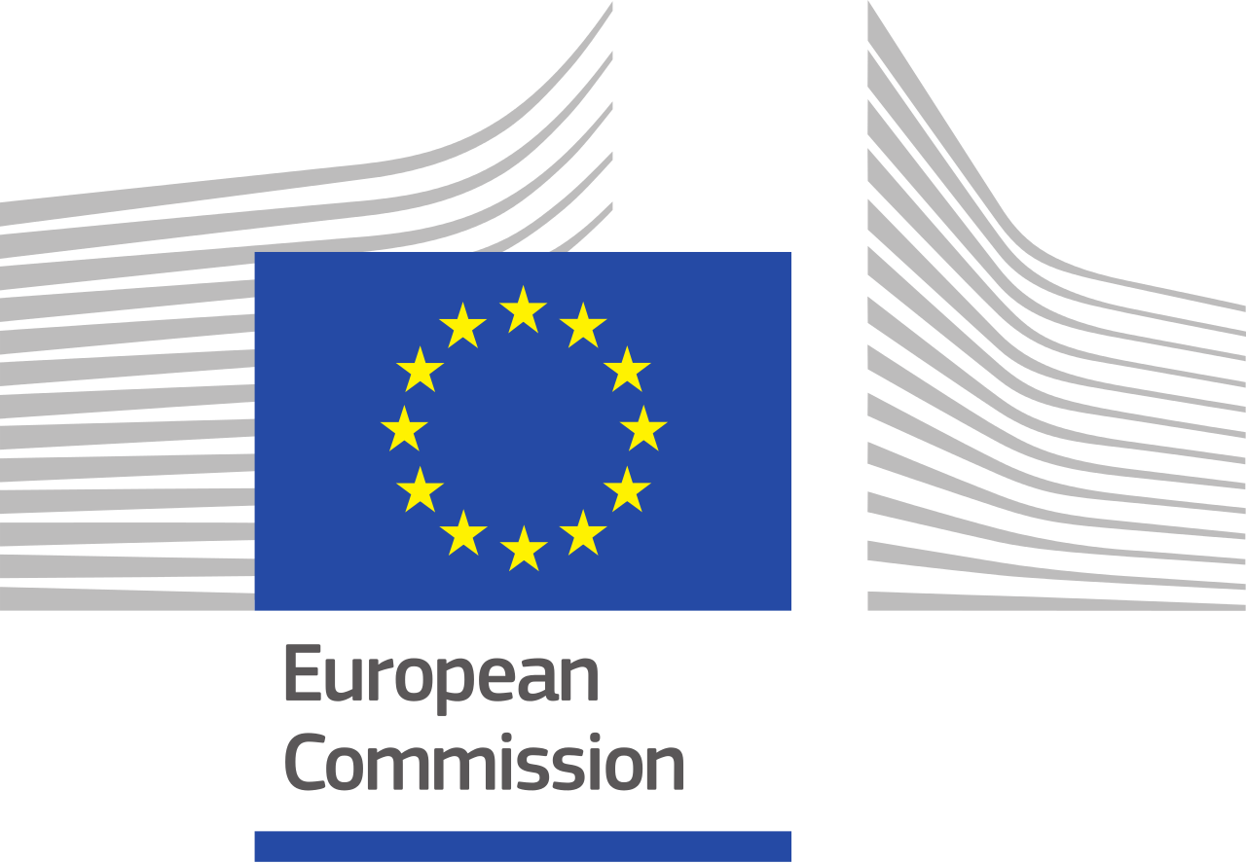

Directorate General for Agriculture and Rural Development

Preparatory action
EU plant and animal genetic resources in agriculture

AGRI-2015-EVAL-09

Strategy for project:

Development & promotion of the original Filderkraut/Filderspitzkraut

6 February 2017

CONTENTS

Introduction 1
1. Summary and general aims of the project 1
2. Genetic resources involved in the project 2
2.1 History 2
2.2 Characterization studies 3
3. Valorisation 4
3.1 Description of the value chain 4
3.2 Valorisation objectives 6
4. Governance of the project 6
5. Capacities, budget and funding 7
6. Status and plans of the project 7
6.1 General strategy 7
6.2 Business plan 7
6.3 Implementation plan 7
6.4 Breeding plan and other technical issues 7
6.5 Governance and legal issue 7
7. Expected inputs from support team 7
7.1 Activities 8
7.2 Planning 9
8. Ex ante analysis of the pre-project 9
8.1 SWOT analysis 9
8.2 Conclusions 10
9. References 10

Introduction
This project is dealing with the safeguard and valorisation of a particular soft wheat landrace named Solina, cultivated in the mountains of the Abruzzo Region, in Central Italy. Solina wheat is a good example of how plant genetic resources can play a key role in rural areas, guaranteeing survival of agricultural activities in marginal areas. The process of dynamic conservation of the landrace is based on its cultivation and use by the farmers in its area of origin (the so called conservation through use). In the last years, traditional wheat varieties have gained increased interest by citizens/consumers looking at wheat products with healthy and specific nutritional characteristics. In this light, Solina wheat has strengthened its market opportunities and is facing new opportunities and threats if not well managed.

1. Summary and general aims of the project
“The challenge in this project lies in bringing back landraces which have been conserved thanks to the tenacity and stubbornness of a few to become the new heritage of all”
Dalla Ragione et al. (2004)
Before the end of last century, the Solina wheat was practically unknown, cultivated only by few old farmers on the mountains: this genetic resource was therefore at high risk of erosion and abandonment. In this framework, in 2007 the Consortium for the Solina of Abruzzo was founded, with the main aim of starting a process of description, characterization, rescue, reintroduction and commercial development of the variety and its flour. The Consortium had a sudden, initial success, also benefitting of the general strengthening of grass root movements, which aimed at the rediscovery of traditional crops and food, both in Italy and across Europe. This led to a certain degree of popularity of the Solina wheat in the media and among consumers.
The sudden increasing of the popularity about the Solina wheat among a wider public has paradoxically determined the emergence of new risks for the Solina’s conservation and for its sustainable use in the area of origin. In fact also farmers outside of its traditional cultivation and adaptation area became interested in the cultivation of this crop. The Solina, usually grown on the mountains, is now cultivated also on the plains with different climate and soil fertility. This can have two negative side effects: on one hand, the changed selection pressure on the variety can change the frequency of its characters, ultimately reducing the genetic diversity of Solina. On the other hand, the competition on the product can pull out of the market the traditional farmers based on the mountains where, compared to other areas of production, the yields are lower and the costs of production are higher.
In the framework of the situation described above, the general aim of this project is to plan and implement adapted and thorough commercial strategies for the Solina wheat, which can contribute to a sustainable conservation and use of this variety in its area of origin, avoiding the risks already mentioned.

2. Genetic resources involved in the project
Solina is a rather tall wheat variety (120-130 cm) grown on the mountain areas of the Abruzzo Region, in Central Italy. In particular, the main areas of production are the whole Aquila province and the areas of the provinces of Pescara, Chieti and Teramo located above 750 metres on sea level.
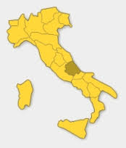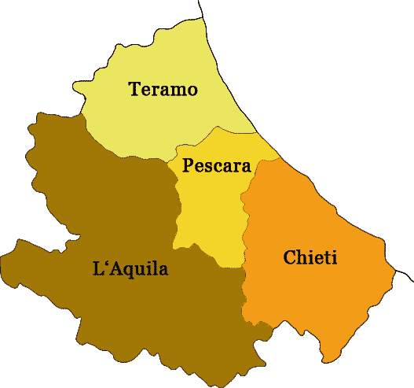
Figure 1: The Abruzzo Region and its provinces
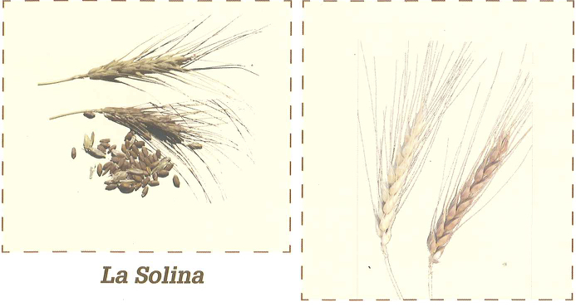
Solina wheat is thus competitive with weeds, very rustic, can resist for months under the snow and can grow on soils, which are not particularly fertile. Indeed, excessive fertility can easily cause lodging. Furthermore, for its characteristics, Solina wheat is particularly well suited for organic and low-input farming systems and for cultivation in marginal areas.
Figure 2: The Solina wheat

2.1 History
Historical documents testify the strong symbolic value of the Solina wheat in the Abruzzo region, and particularly among the population of its mountainous and marginal areas. First written traces of Solina wheat can be found in notary acts regarding commercial transactions taking place during the fair of the town of Lanciano around the 1500s and then copied by local historian Corrado Marciani in the 1900s. For instance, one of these acts (1565) describes the sale of Solina wheat “not infected and not damp”, i.e. of excellent quality, between two farmers. Another historical document, the essay by Michele Torcia “Pel paese de’ Peligni”, describes the bread made from Solina wheat as one of the best of the whole region.
The traditional presence of Solina wheat in Abruzzo region is also evident since a number of local aphorisms refer to this crop and its high-qualities: “Solina wheat is the mother of all wheats”, “the Solina wheat flour improves all others”, “if a farmer wants to go to the mill, he must grow Solina wheat”. The traditional popular wisdom, which forms the ground for these aphorisms, testifies the extreme adaptation of the Solina wheat to the Abruzzo mountain areas (e.g. its adaptation to low temperatures and its productive stability), as well as its superior organoleptic characteristics.
Traditional uses of the Solina wheat flour are mainly bread making, but also production of fresh pasta and traditional pastries. The aromas and perfumes that the Solina flour gives to traditional bread, also thanks to the traditional processing methods, are considered unique. Slow fermenting and the use of sourdough are essential steps of the process to fully valorise the features of the Solina wheat; traditionally, families used to prepare their sourdough at home, exchanging it with whoever needed it.

2.2 Characterization studies
From 1996 the ARSSA (Regional Agency for Rural Development of Abruzzo), which collected and studied local germplasm across the region, revealed the great diversity still present in mountain fields, raising the awareness among Solina wheat producers, which founded a Consortium of producers. At this time started the project “Collection, conservation and study of germplasm of species of autochthonous agricultural interest in the Abruzzo Region” funded by the European Union jointly with the Faculty of Agriculture of the University of Perugia. The scope of the project was to become acquainted the local varietal heritage by an initial investigation, after which to characterise and conserve the varieties identified. The initial conservation strategy envisaged was only ex situ, with a number of in situ catalogue fields only for fruit trees. Twelve species were examined: soft wheat (Solina), durum wheat, spelt, lentils, chickpeas, beans, black eye beans, peppers tomato and apple, pear and almond tree. The move from ex situ to on farm conservation, therefore, was natural and was applied in the second phase of the project, this time funded by the Ministry of Agriculture, Food and Forestry (MiPAAF) within the National Biodiversity Project. In this new phase, the range of subjects was broadened in order to emphasise increased closeness to the territory to include the Park of Majella, the Province of L’Aquila, the Regional Botanic Garden and the Peligna Upland Community. The idea of using agricultural biodiversity as a key for rural development began to take shape creating a relationship among the various economic actors that go to make it up: farmers, schools, restaurants and tourism facilities. From these projects Solina wheat began to be characterised, its diversity studied also with molecular markers and its quality, health and nutritional characteristics pointed out.
In the last seven years, two EU-funded research projects have carried on studies on Solina wheat compared to other landraces or to commercial varieties: Farm Seed Opportunities – www.farmseed.eu – in the period 2007-2009, and SOLIBAM – www.solibam.eu - in the period 2010-2014. The results of these projects showed that this variety is characterized by considerable highly diverse and complex genetic structure, divided in four genetic groups, mainly caused by two factors: the diverse mountain conditions in which small farmers developed and maintained the variety and the fact that Solina has been continuously cultivated by farmers over time without passing through a period of ex situ conservation (Khan, 2013).
Indeed, Solina can be considered as a true landrace according to the following definition:
“[…]a landrace is a dynamic population(s) of a cultivated plant that has historical origin, distinct identity and lacks formal crop improvement, as well as often being genetically diverse, locally adapted and associated with traditional farming systems.”
(Camacho Villa et al., 2005)
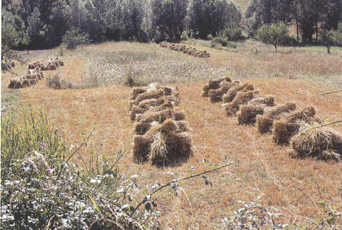
Figure 3: Solina field during harvest

3. Valorisation

3.1 Description of the value chain
The Members of the Consortium cultivated the Solina wheat and other local varieties, in some cases reintroducing them in their farms. The local varieties grown were mostly of cereals and legumes, although there are also some horticultural and fruit varieties. In addition to the Solina wheat, a durum wheat landrace (Ruscìa) and an emmer variety from Central Italy are being currently grown. At the moment the members of the Consortium are cultivating 52 hectares of Solina.
Milling and processing activities are managed directly by the farmers of the Consortium that control all the process and sell the produce (e.g. flour, pasta or bread). In order to do so, the Consortium has developed links with millers, bakers and pasta-makers that share the vision and the objectives of the project. The relationship with bakers is particularly difficult because Solina flour is not so strong and therefore it doesn’t perform well in industrial bread making. Bakers should be aware of that before trying Solina flour and should change or adapt their processing methods to the characteristics of the flour. As shown in Fig. 4 the Consortium is working with two millers, one pasta-maker and 3 bakers.

Figure 4: valorisation network of the Solina Consortium
In the early stages of the Consortium’s life, direct sales by individual farmers were the only marketing strategy adopted. In this framework, the main target of the producers of the Consortium was small groups of environmentally conscious consumers (Gruppi di Acquisto Solidale – GAS) and collective buying groups. Over time, the name of Solina wheat started to be well-known by a broader range of local consumers, who are not necessarily organized in groups, but still appreciate and understand the added value of the processed products made with Solina wheat, in terms of health, quality and traditional values. Recently, the demand of Solina wheat flour increased beyond the local level, and consortium members sell a very small part of their product outside the region.
Together with the National Park Gran Sasso e Monti della Laga and Majella, the members of the Consortium developed a network of restaurants and agro tourisms using Solina for the preparation of their dishes.
The Consortium is also member of the Terraviva consortium, which gathers together around thirty cooperatives of farmers of the area. Terraviva manages a small shop in the city of Sulmona where also processed products made with Solina wheat are sold. Each member of the shop, including Solina wheat Consortium, pays a share of the income from the sales of its products to support the expenses of the shop.
Finally, the Consortium is part of the Slow Food Presidium project and the whole production is certified as organic and Solina is listed in National Catalogue of Traditional Food managed by the Ministry of Agriculture.

3.2 Valorisation objectives
The main aims of the current valorisation project are the following:
- To find new marketing channels for the products already produced from the Solina wheat, namely flour, dried pasta (which is made with durum wheat by law), crackers, and cakes and baked products.
- To test and launch on the market new products produced from the Solina wheat, for instance seitan.
- To set up a coordinated and integrated communication and marketing strategies for all the members of the Consortium so as to avoid the risks described above.

4. Governance of the project
The legal entity in charge of the project is the Consortium Solina of Abruzzo, established in 2007 with the aim of giving value to local productions, based on local agrobiodiversity and which were becoming increasingly marginalized. The Consortium gathers members from the whole Aquila province and from part of Chieti and Pescara provinces. Currently the members of the Consortium are 11 (see the table below) but many farmers have requested to enter. The Consortium is favourable to enlarge its member base, hence involving more farmers in the safeguard of Abruzzo’s agrobiodiversity. However, broadening the composition of the Consortium should take into account that the cultivation of each genetic resource (Solina wheat or other local Abruzzo varieties and species) still occurs in the traditional areas where they acquired their features, thus respecting the Consortium’s overall philosophy.
Figure.5 - Members of Solina Wheat Consortium
Name | First name | Name of farm | Place | Role in the Consortium (if any)
Carboni | Gaetano |  | Civitaquana (PE)
D'Alfonso | Alfonso | Terre del Tirino | Capestrano (AQ) | vicepresident
De Santis | Tonino | Peppone | Introdacqua (AQ) | Administration council
Maggi | Simone |  | Secinaro AQ
Battista | Bruna |  | Goriano Sicoli AQ | Administration council
Nolletti | Nunzio |  | Collepietro (AQ) | Administration council
Santavicca | Stefano |  | Barisciano (AQ)
Silveri | Donato D. | Casasole | Castelvecchio Subequo AQ | president
Valente | Fabrizio | La Dispenza | Tagliacozzo (AQ)
Raschiatore | Ettore | Coop. Supinum | Trasacco (AQ)
Verna | Paolo | Il Fortino | Capestrano (AQ)
All producers associated to the Solina consortium are organic farmers and use and reproduce their own seed. As of today, a collective process for managing a more careful and systematic maintenance of seed quality has been started. This process also aims at increasing the available seed volumes, which are currently quite low.
The Consortium is also working closely with the National and Regional Parks located in the Region (e.g. Gran Sasso/Monti della Laga and Majella).

5. Capacities, budget and funding
At the moment the Consortium doesn’t have any supports from public Institutions or bodies to carry on its valorisation objectives.

6. Status and plans of the project

6.1 General strategy
The main objective of the strategy is to consolidate and stabilize both the production and the marketing of processed products made with Solina wheat. These objectives will be pursued while strengthening and protecting the link between Solina production and the area of origin and diversification of the variety. This will allow protecting the authenticity of the variety while recognizing the contribution of farmers working in marginal areas to the conservation of the local genetic resources and cultural heritage. This experience would also allow the Consortium, in the future, to broaden the range of cultivated products to other species and varieties (other cereals and legumes), using similar approaches.

6.2 Business plan
In the next month the Consortium has planned to manage collectively the marketing of the different products made with Solina wheat and also to implement a common communication strategy that can present the project to the wider public. A technical aspect that will be improved is the linkage with bakers that at the moment are not able to process the Solina flour because has different characteristic compared to modern varieties. The Consortium will organise training for bakers on traditional bread making, using sourdough and not just yeast in the fermentation process. The other point that the Consortium will develop is the creation of new produce made by Solina, as for example cookies, seitan.

6.3 Implementation plan
Not started.

6.4 Breeding plan and other technical issues
The Consortium foresees for the future to better manage seed production collectively within its members. The aim is to have a good seed quality and also to organise seed production in manner to maintain the genetic diversity of the population.

6.5 Governance and legal issue
At the moment Solina is not registered in the official catalogue as conservation varieties. The Consortium is in the process of doing the registration through the Region and the Ministry of Agriculture. This project will support the Consortium in doing the registration.

7. Expected inputs from support team
Structuring a detailed business plan is the main tool to reach the objectives mentioned in part 3 and will be the core input from the support team. The business plan should reflect the Consortium values of conservation and of sustainable use of agrobiodiversity, while responding to consumers’ demand for healthy and high quality foods. A more structured marketing strategy would also allow operating more collectively as a consortium, compared to what happens now. In fact an important step to implement, also in the light of the growth in consumers’ interest, is the beginning of a process to sell the product collectively, namely as a Consortium and not as individual farmers.

Another important step to be included in the business plan - as it can contribute to the valorisation objectives - is the development of a logo and of a packaging solution to identify the products from the Consortium. This step is a tool to further strengthen and promote the collective conservation and sustainable use of mountain agrobiodiversity, starting from the Solina wheat.

7.1 Activities
According to the Consortium valorisation objectives the following activities can be carried on with the support team.
- Develop the Solina business plan as said above.
- Develop the Solina Communication strategy:
  - Develop communication tool for the wider public that present the history of the landrace focussing also on its nutritional and health qualities;
  - Develop the knowledge about Solina and associated knowledge (e.g. recipes) on the web site and other social media;
  - Develop tools to disseminate to bakers about traditional bread making with Solina flour;
- Develop a new and collective Marketing strategy:
  - Develop the collective vision of the Consortium;
  - Develop the new logo of the Consortium;
  - Develop the new label for the different produce commercialised by the Consortium;
  - Develop the new web site of the Consortium that can present all the history and the quality of Solina and also the activities of the Consortium;
- Study the technical feasibility and the consumer acceptance of the new products made by Solina flour;
- Support the application for registering Solina as conservation varieties according to the directive 62/2008/EC;
- Support the Solina seed system also through the use of ICT tools that can help the control of seeds cultivated by the different members of the Consortium (e.g. database) also in connection with on-going EU research projects (e.g. DIVERSIFOOD and CAPSELLA).
The Solina Consortium, under the guidance of its Administration Council, will implement the project. Rete Semi Rurali (www.semirurali.net), the Italian seed network of which the Solina Consortium is a member, will provide technical and institutional support if and whenever needed.

7.2 Planning
The activities will be implemented according to this preliminary timetable. It will important to establish good relationship with the Consortium in order to validate all the activities that will be performed. For this reason we planned to set up at the beginning a core team within the Consortium (max 3 persons) that will manage all the communication between the Consortium and the support team. It will be also important to plan local workshops with farmers and other stakeholders during the definition and implementation of all the activities in order to have a more inclusive and participatory approach that will be the guarantee of the success of the initiative.
Activities | First phase | Second phase | Third phase
Establishing a core team within the Consortium
Organising local workshops with farmers and other stakeholders
Defining the business plan
Defining the communication strategy
Defining the marketing strategy
Defining new products
Registration as conservation variety
Support Solina seed system

8. Ex ante analysis of the pre-project

8.1 SWOT analysis
Strengths  Farmers are interested in joining the Consortium and cultivating Solina  Some members of the Consortium have sufficient knowledge and skills to carry on the project  There is enough technical and scientific knowledge about Solina wheat thanks to previous projects.  Quality and health characteristics of the Solina flour. | Weaknesses  Solina wheat is not registered to national catalogue, as conservation varieties therefore the seeds cannot be marketed.  It took many years of work to set up the Consortium and convince farmers to act together. This process is very fragile and should be carefully handled. It is not done once for all.
Opportunities  There is a strong interest by different markets on the produce.  Solina is now a well known “name”, not only in the region of origin.  The Consortium has good connections with public institutions (e-g- national and regional natural parks), restaurants networks, small shops and schools. | Threats  It is difficult to maintain a collective work within the Consortium (for seed production and management and marketing of the produce) when the economic pressure on Solina is so high.  The economic interest of farmers outside the area of origin can change the genetic composition of the landrace and put farmers of the Consortium out of the market.

8.2 Conclusions
The case of Solina wheat can turn in an example of how diversity linked with sustainable farming systems can support the development of marginal and mountain areas. Moreover the establishing of appropriate marketing and communication strategies that will promote Solina diversity and the farmers living on the mountains will be an interesting case studies for finding the right balance between marketing pressure and sustainable use of plant genetic resources. In fact, as said before Solina wheat is now facing new risks linked to overexposure on the market and the high demand from consumers not only in the Abruzzo Region. In order to avoid these risks is paramount to sustain the Consortium in the development of collective strategies. These strategies should also lead to a diversification of crop production of the farmers of the Consortium, ultimately improving and protecting their income.
Furthermore, the lessons learnt through the implementation of this project could be applied to other landraces, as an example of conservation through appropriate and fair use.

9. References
ARSSA, 2006. Pane nei Parchi dell’Appennino Centrale - L’itinerario del pane nei Parchi, CARSA.
Bocci R., Synergies between Natural Parks and agrobiodiversity: the example of the Abruzzo, Bocci in The Sustainable Use of Agrobiodiversity in Italy - Report on case studies on article 6 of the International Treaty on Plant Genetic Resources for Food and Agriculture, Riccardo Bocci and Tiberio Chiari (eds.), 2009, IAO.
Curcetti E., Davini G., 2008. Agrobiodiversità: la rete degli agricoltori custodi del Parco Nazionale del Gran sasso e Monti della Laga, Gruppo Tipografico Editoriale.
Dalla Ragione I., Porfiri O., Silveri D.D., Torricelli R., Veronesi F., 2004. Le risorse genetiche autoctone della regione Abruzzo: un patrimonio da valorizzare, ARSSA.
Di Santo M., Silveri D.D., 2004. Le varietà autoctone del Parco Nazionale della Majella, POMAN.
Khan, Abdul Rehman. Réponse à court terme des populations de blé européens aux conditions agro-climatiques contrastées: analyse généetique et premiére étape vers le développement de marqueurs épigénétiques dans les génes précoces VRN-A1. Sciences agricoles. Université Paris Sud - Paris XI, 2013. Français.
Silveri D.D., 2002, Il Recupero delle varietà autoctone abruzzesi: il progetto dell’ARSSA, in Taucci T.
Tavano G., Silveri D.D., 2006, 4 Prodotti tipici di Abruzzo: ricerche analisi sviluppi, CARSA.

